Implementing Nowcasting Intelligent System for Media

Team Members

Part1: Get familiar with the Gretel design and run the tutorials

Generating data for Synrad and running model

Generating data for Nowcast and running model

Part 2: Designing the REST API

Introduction to FAST API

Postman Application JSON Execution

Operations supported by API

Assumptions for Media Nowcasting

Implementation

Deployment of FAST API for Media Nowcasting

Test cases to illustrate how to use the API

Conclusion

References

# 

Implementing Nowcasting Intelligent System for Media

# 

# Team Members

| NAME | NUID |
| --- | --- |
| PRIYANKA DILIP SHINDE | 001524484 |
| KSHITIJ ZUTSHI | 001021288 |
| DWITHIKA SHETTY | 002114630 |

# Part1: Get familiar with the Gretel design and run the tutorials

| NAME | NUID |
| --- | --- |
| PRIYANKA DILIP SHINDE | 001524484 |
| KSHITIJ ZUTSHI | 001021288 |
| DWITHIKA SHETTY | 002114630 |

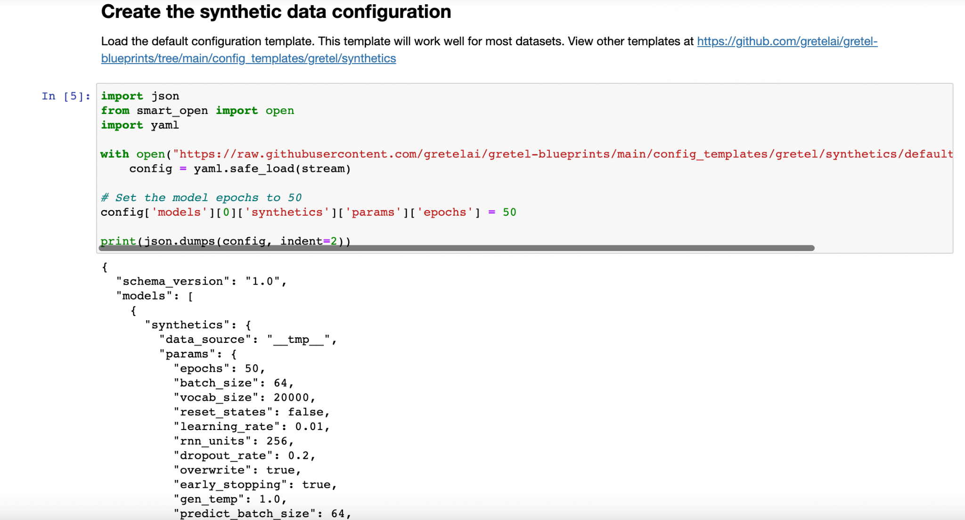

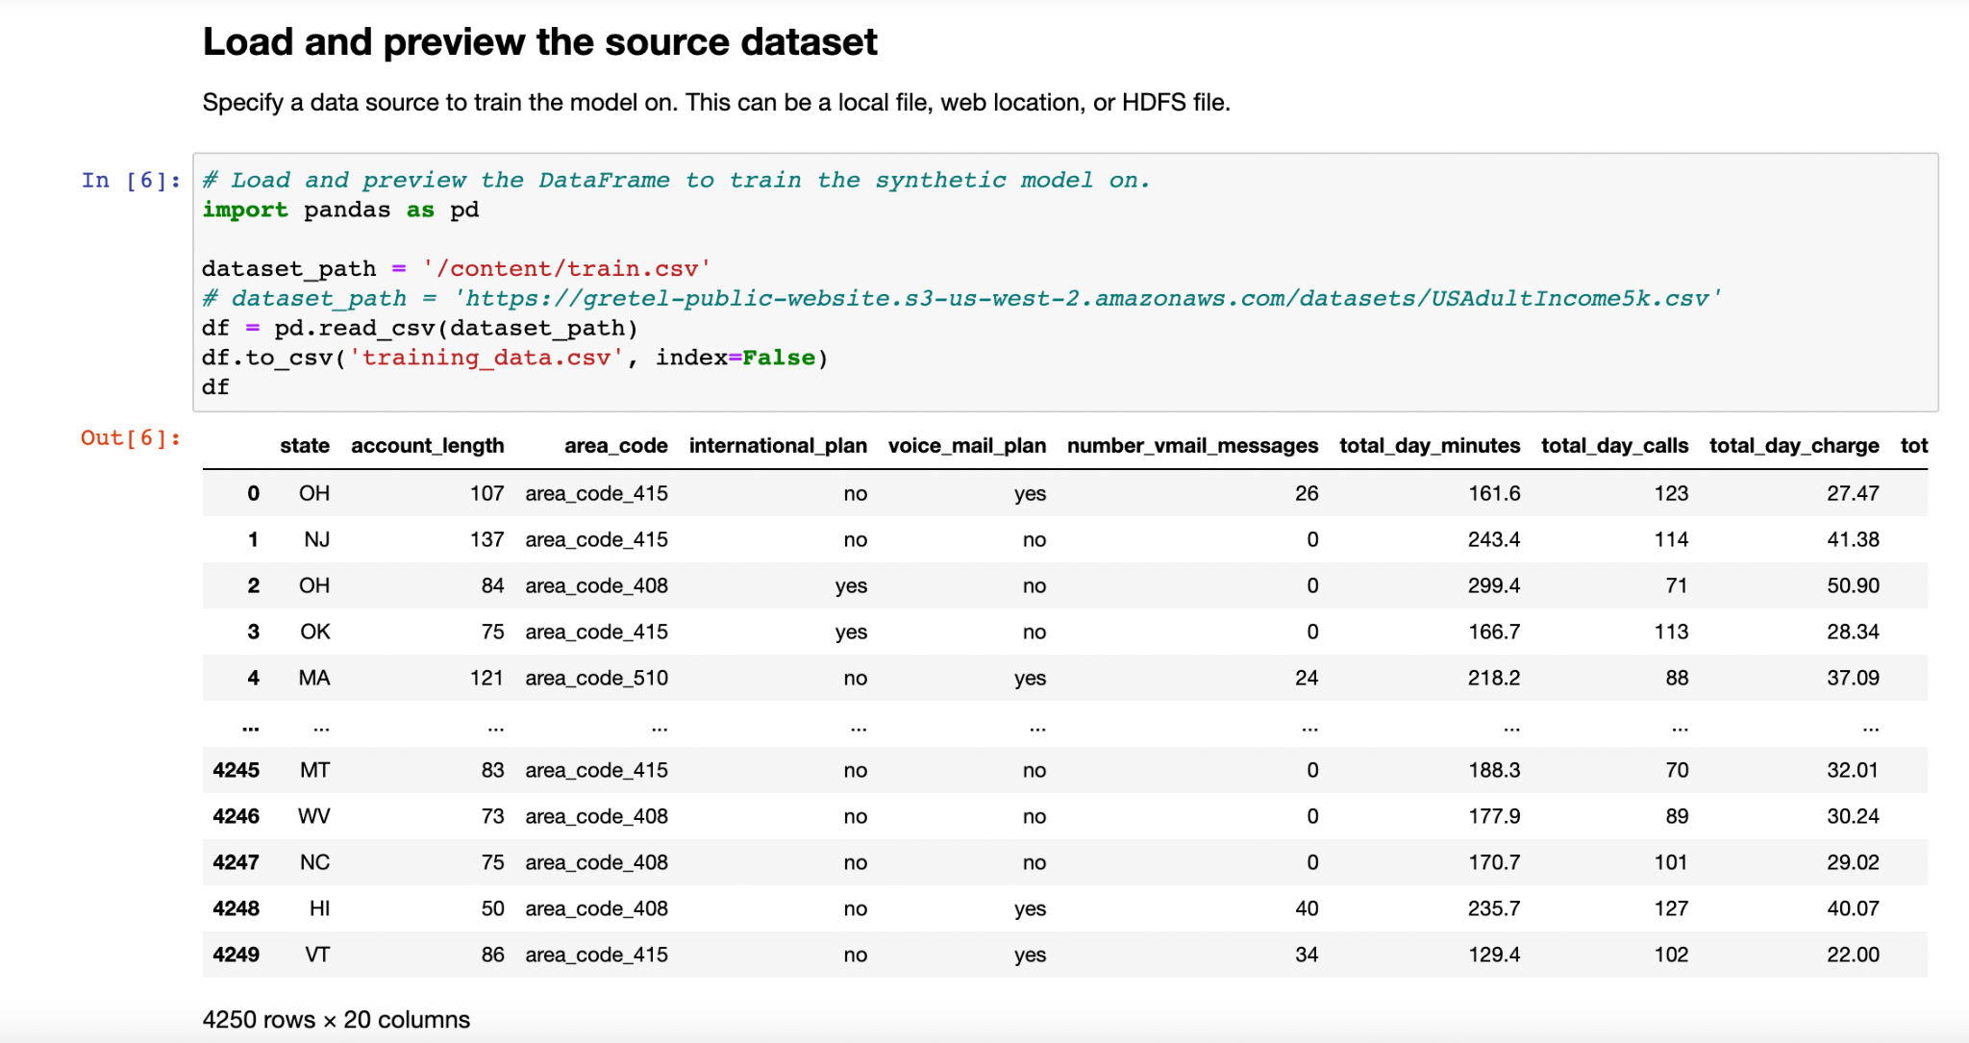

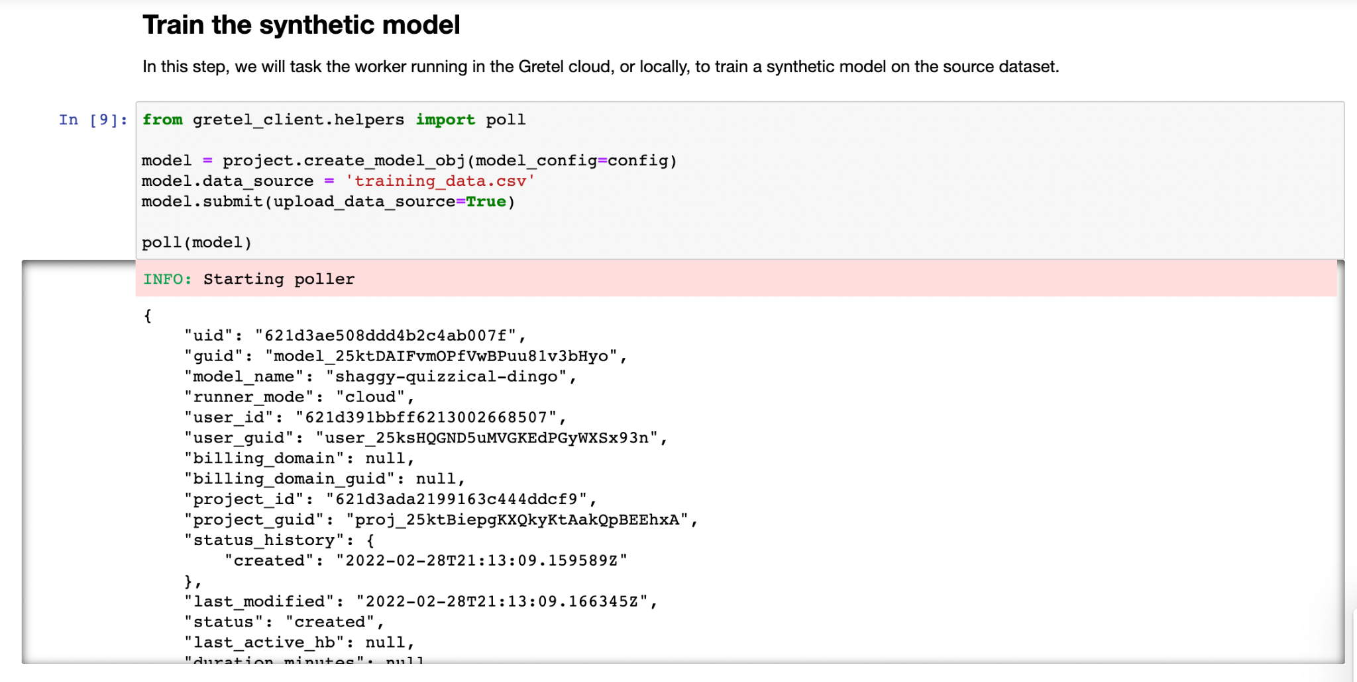

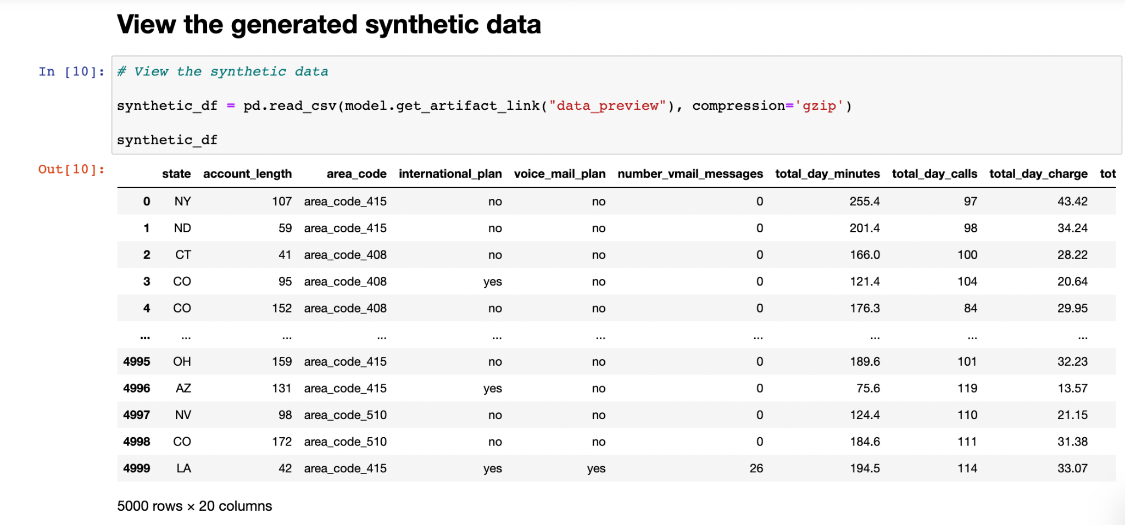

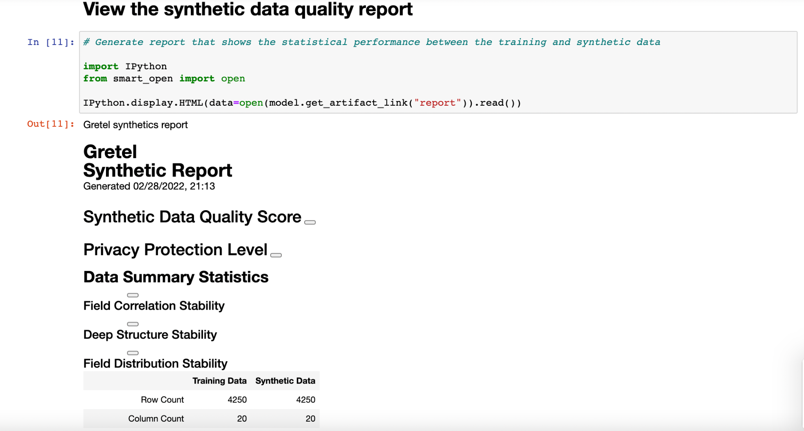

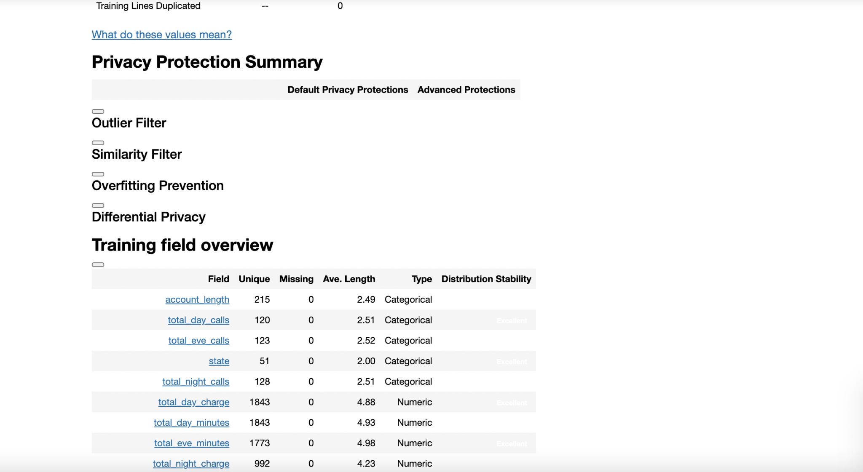

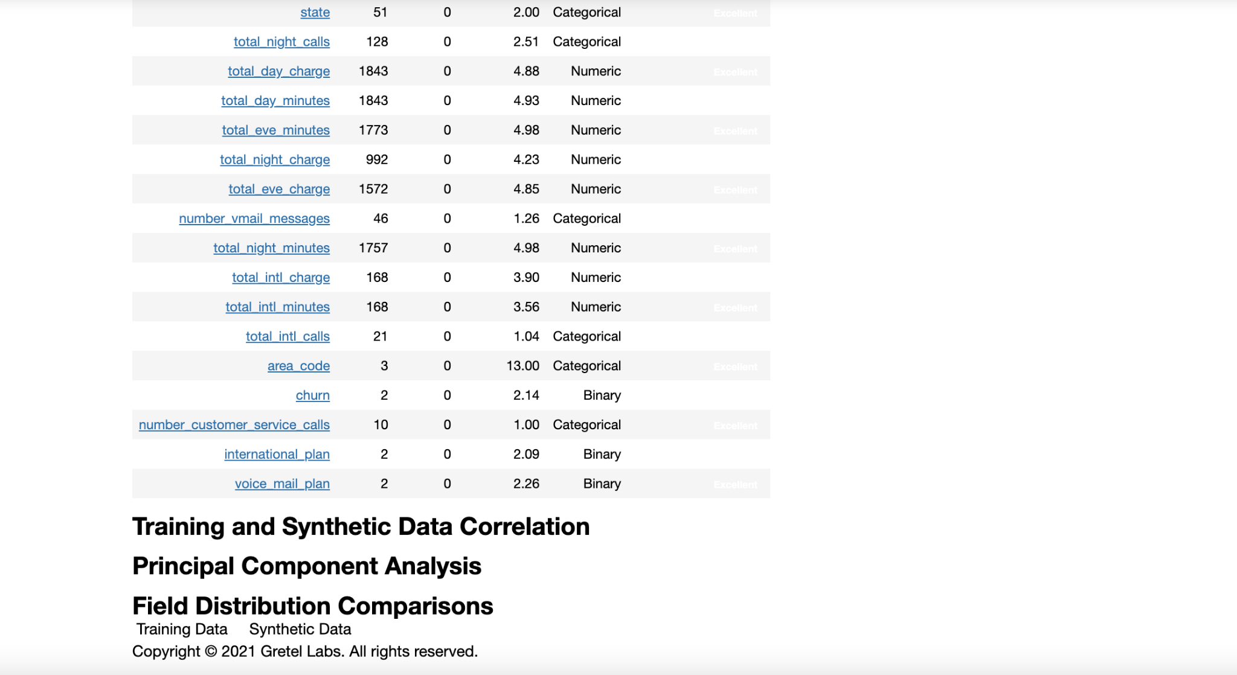

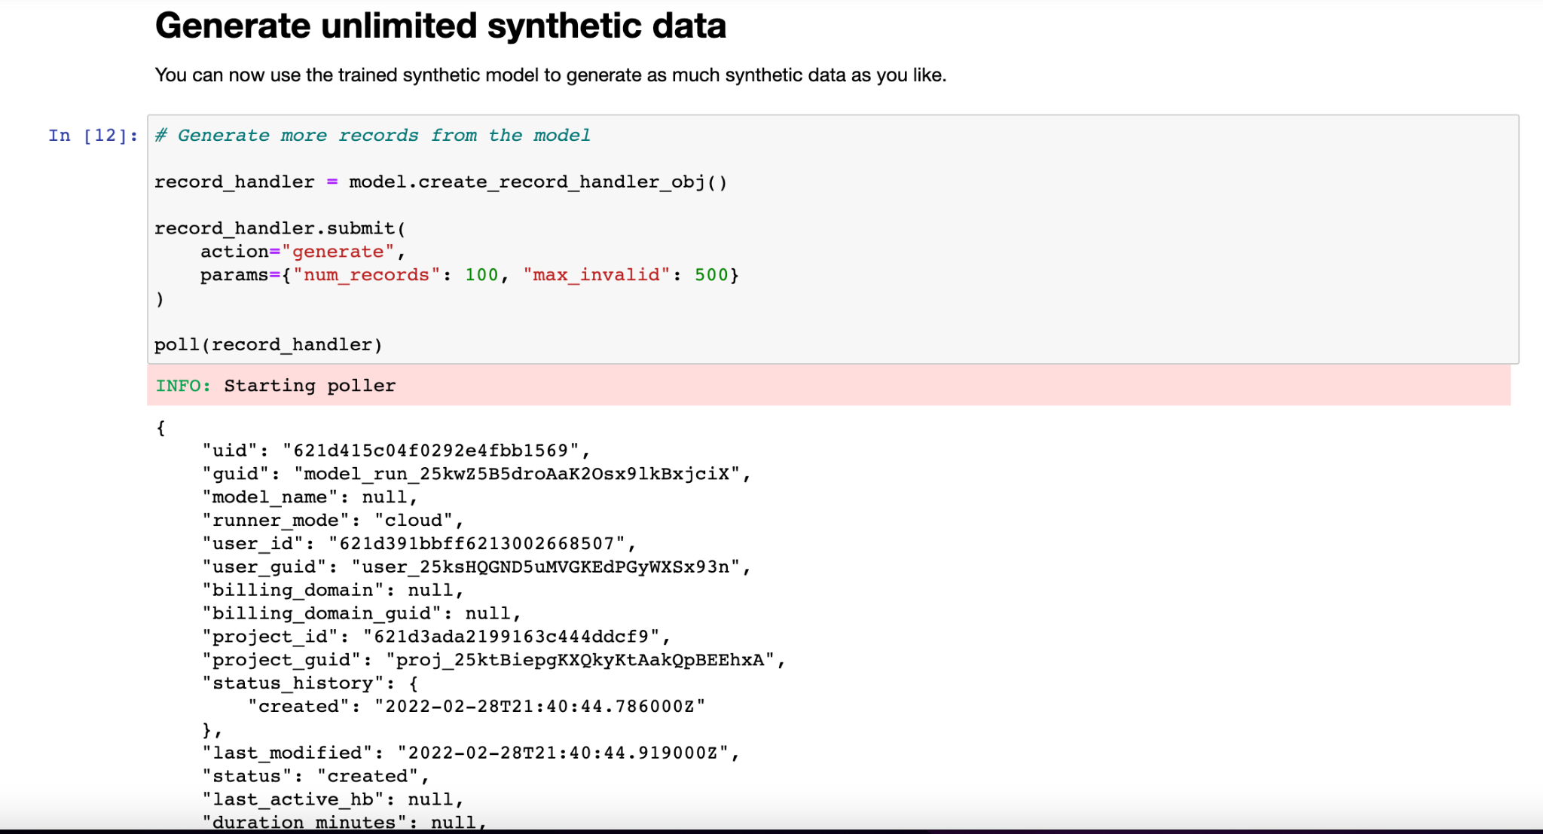

# Part 2: Designing the REST API

## Introduction to FAST API

To try Fast API software as part of assignment, we have tried a tutorial as seen in the screenshot below where in the endpoint i.e article_id will be provided by the user. If an integer is provided it will display the same integer.

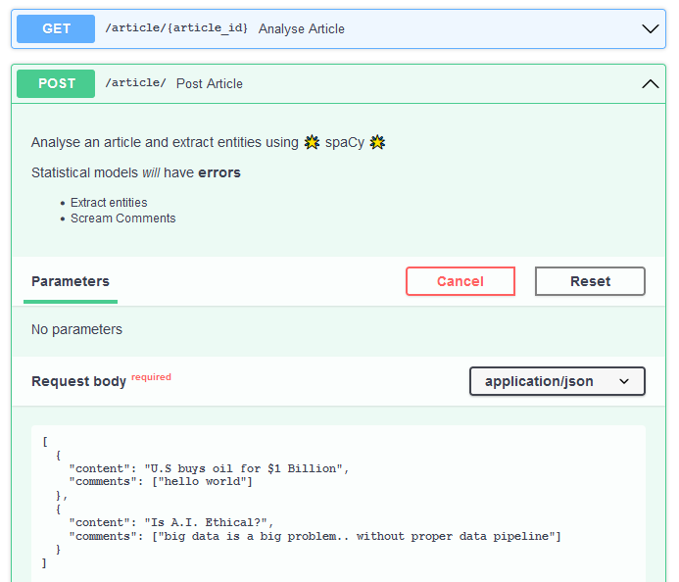

In the below screenshot , when we pass a string “U.S buys oil for 1$ Billion”, by using pre pre-trained machine learning model (nlp) and finding out the entities of the string passed.

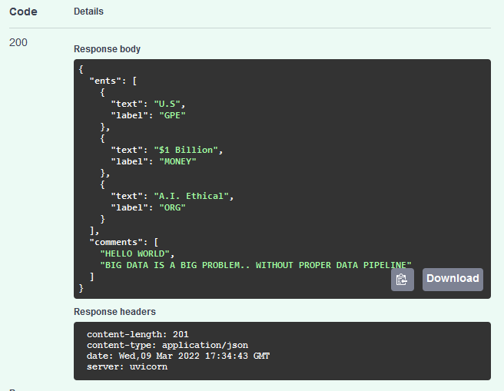

## Postman Application JSON Execution

Executing model in postman by passing JSON

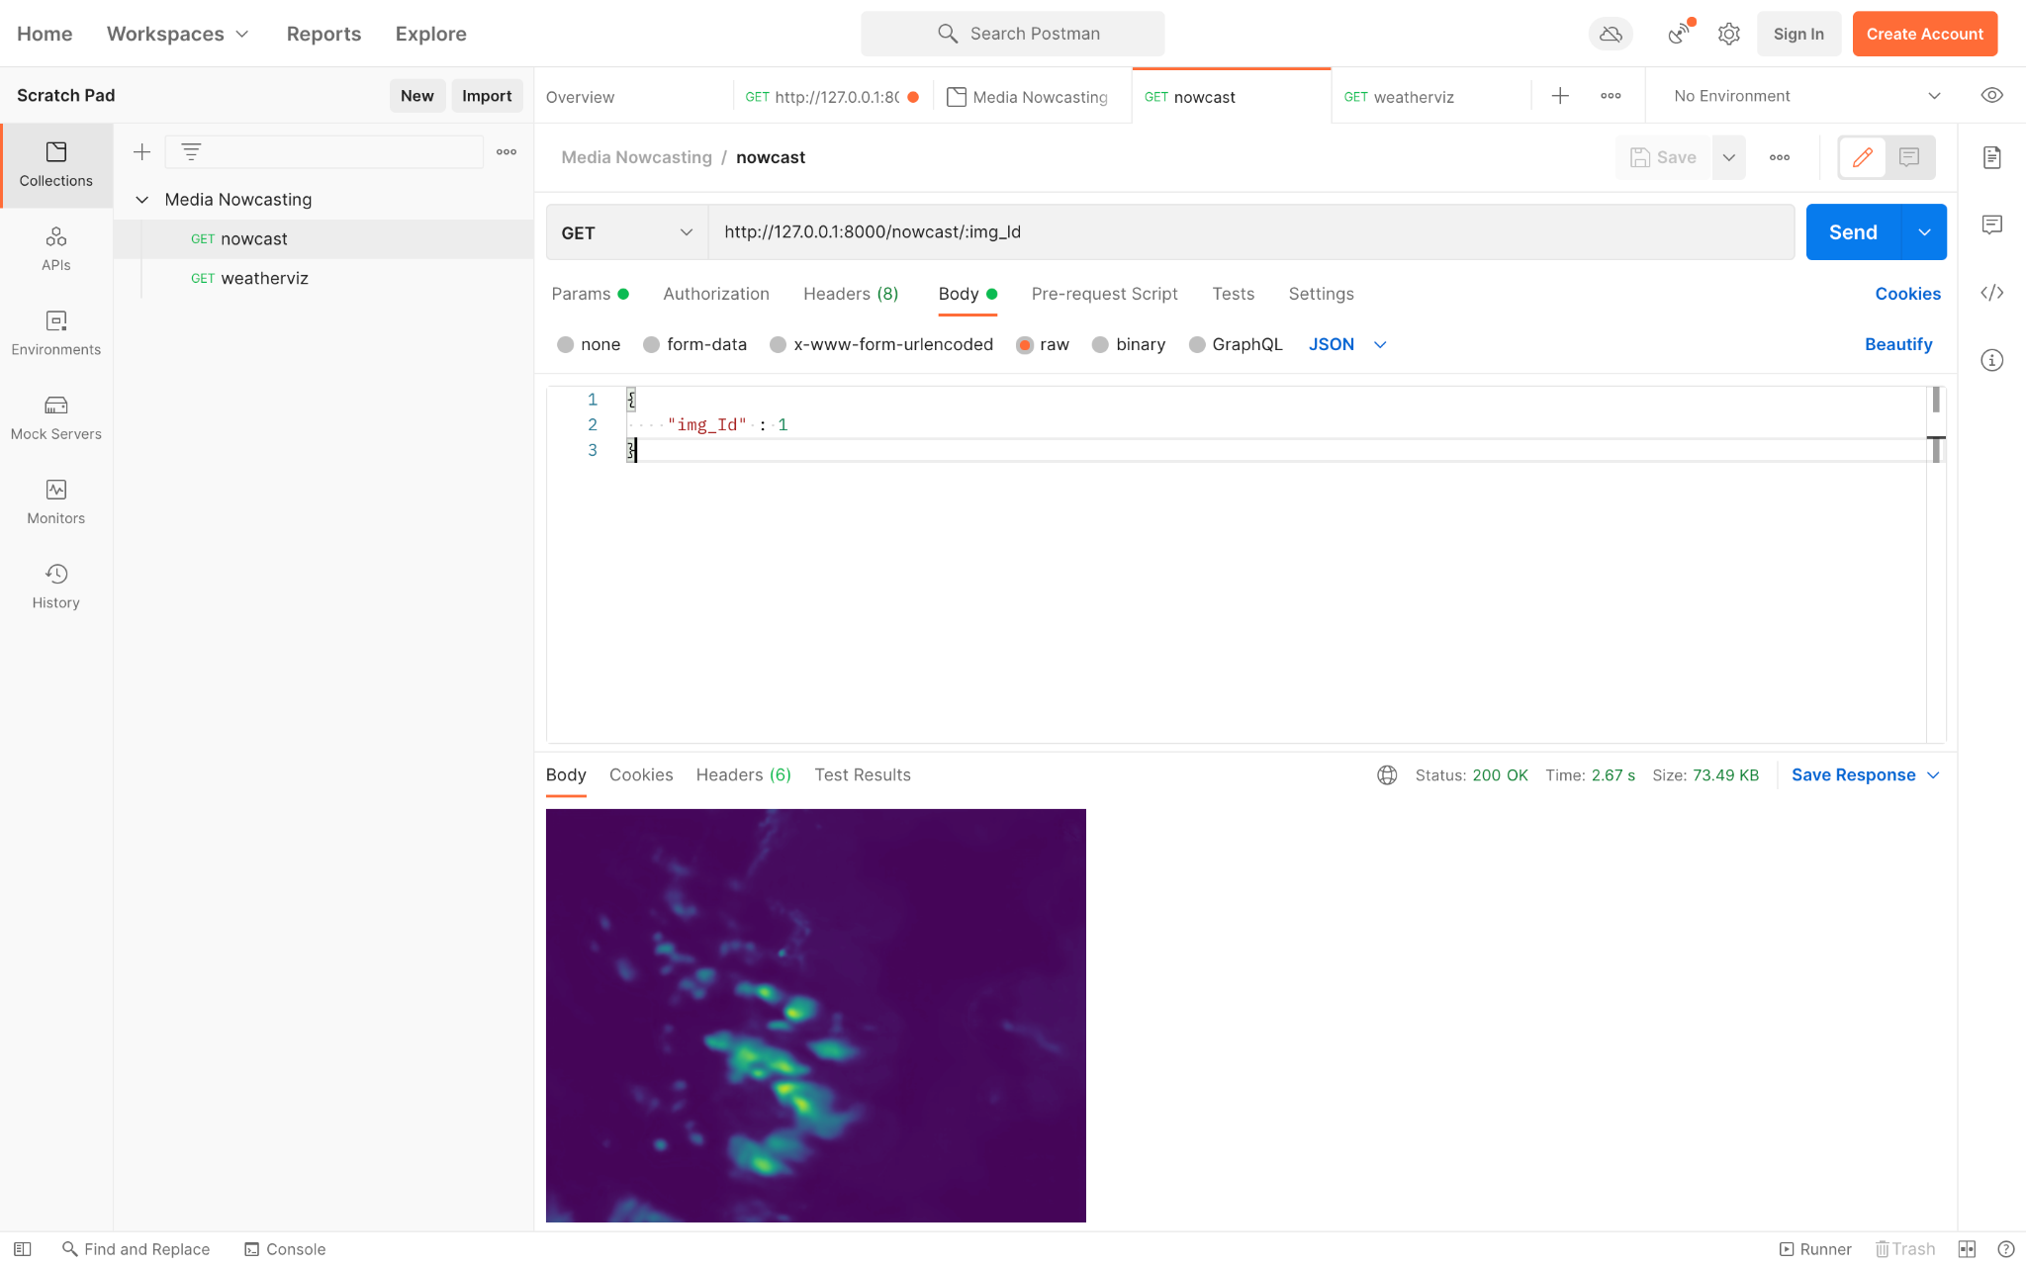

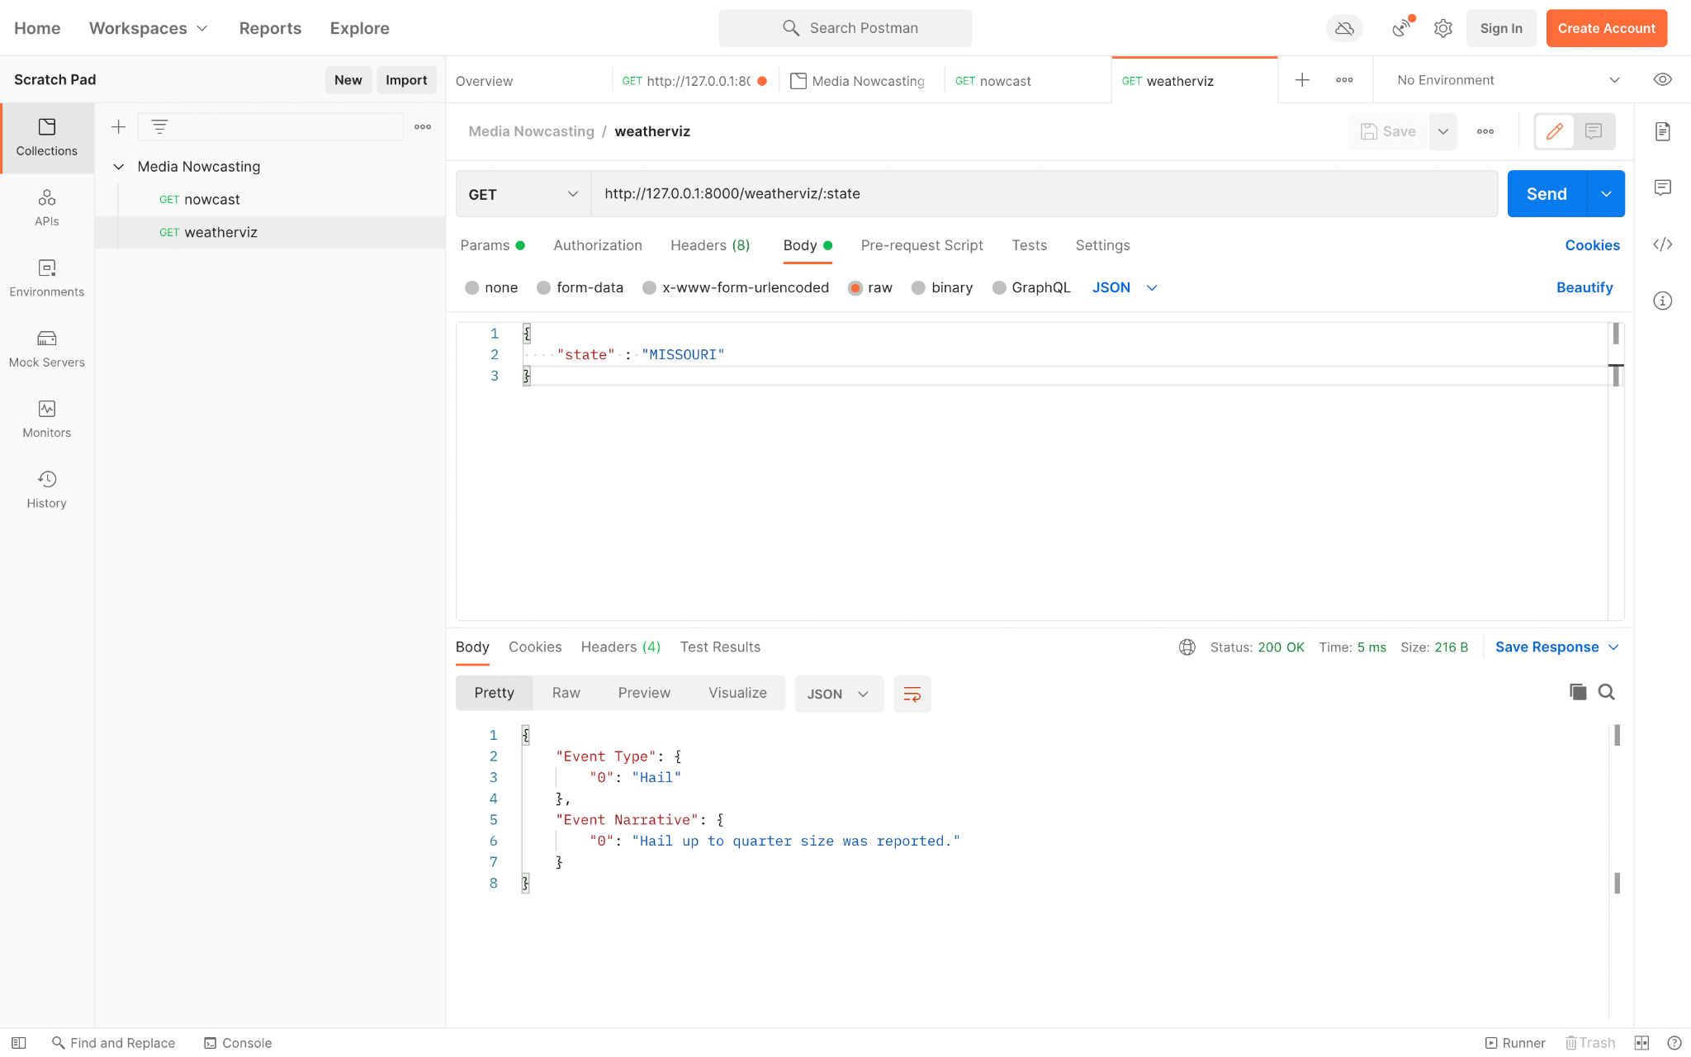

## Operations supported by API

1. Endpoint 1: **/nowcast/{img_Id}**

To render next hour’s nowcasting 12 output images based on their image id that ranges from 0-11 where each

image id represents 5 min interval of nowcasted image.

1. Endpoint 2: **/weatherviz/{state}**

To display the event type and event narrative for selected states from the drop down menu.

## Assumptions for Media Nowcasting

1. We will be generating next hours nowcast and allow users to render those 12 nowcasted images for every 5 min interval.
2. Users can get the event type and event narrative for the selected state from the drop down menu.

## Implementation

## Deployment of FAST API for Media Nowcasting

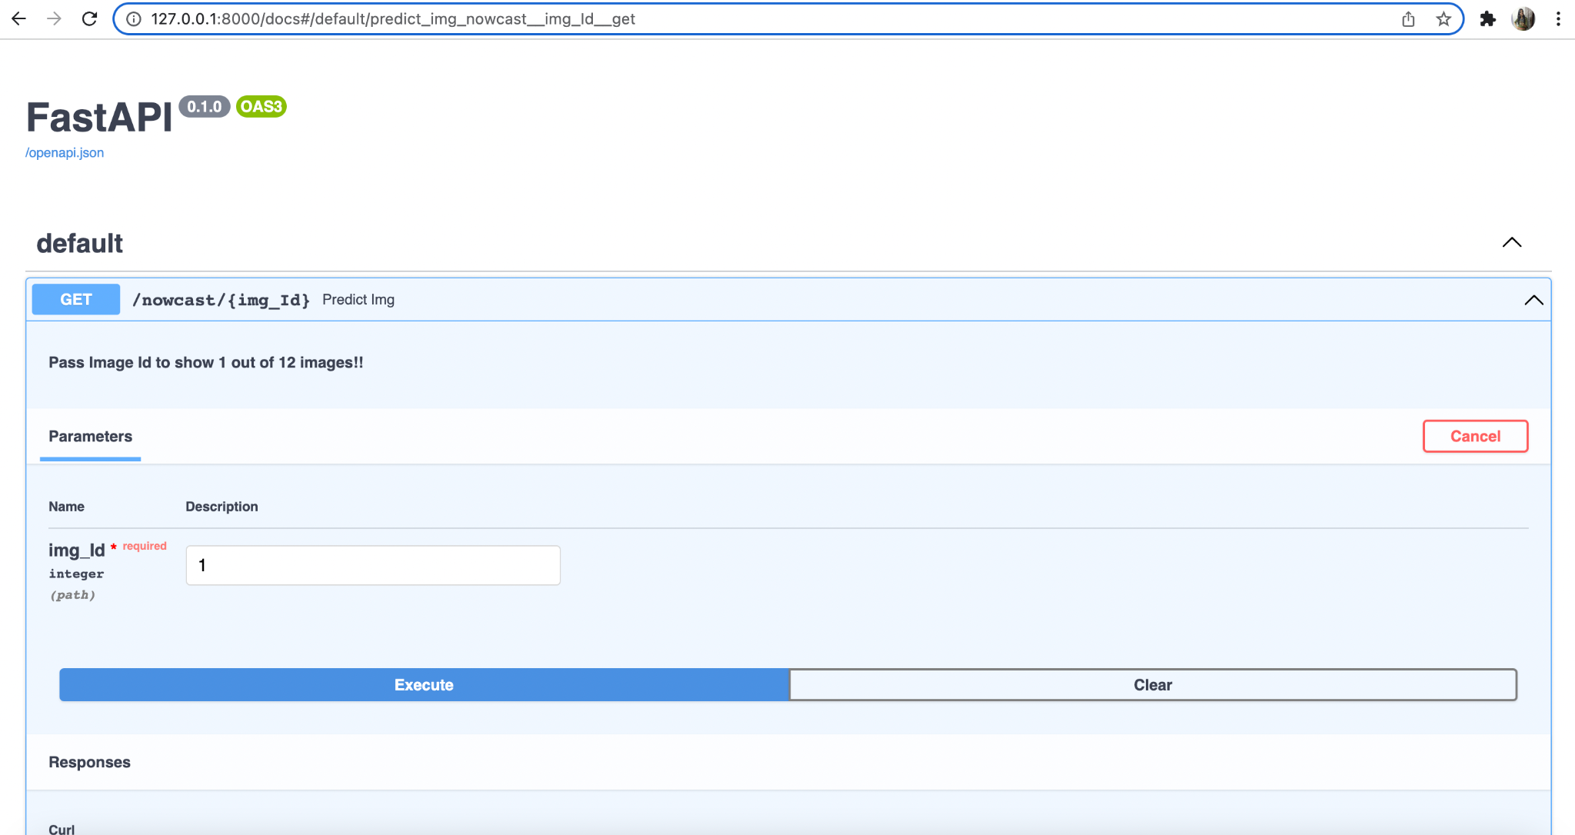

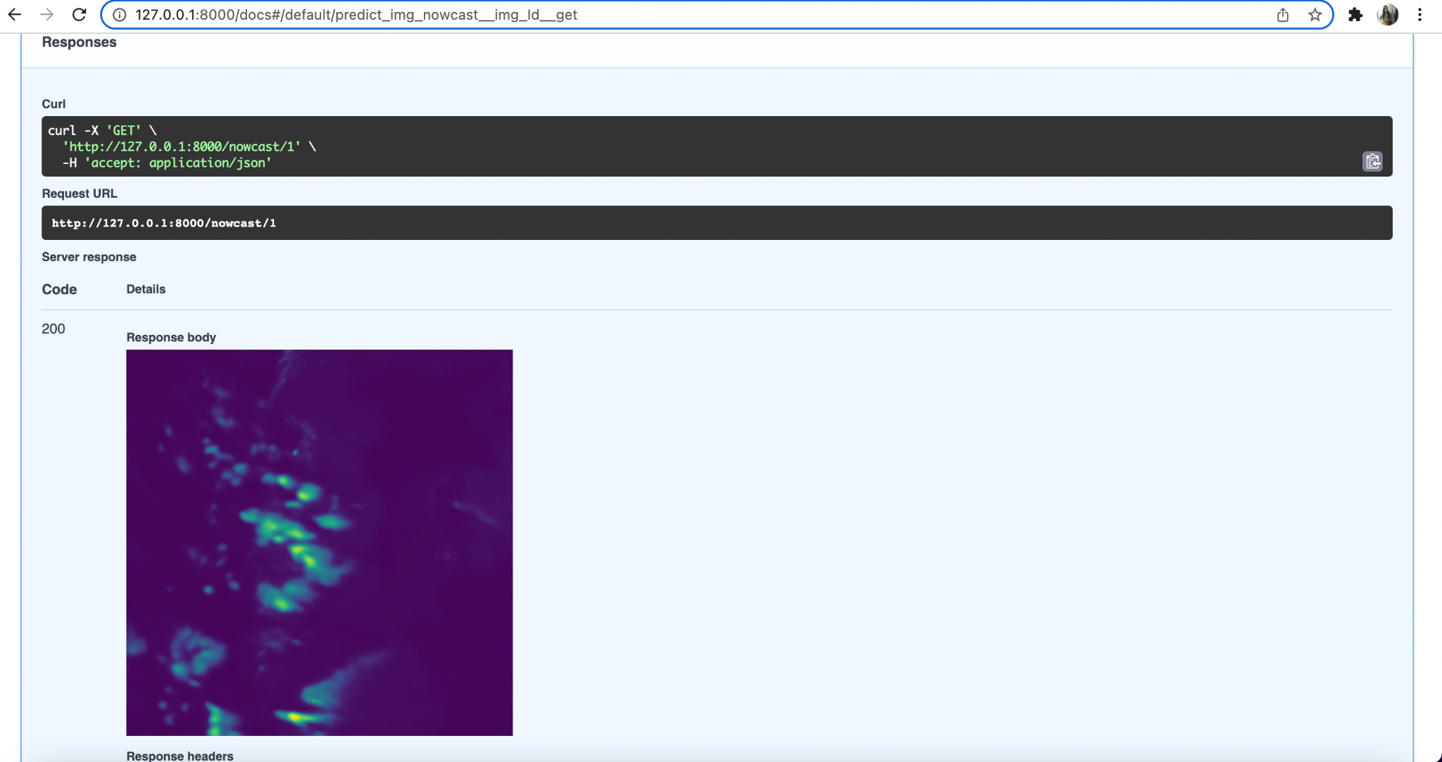

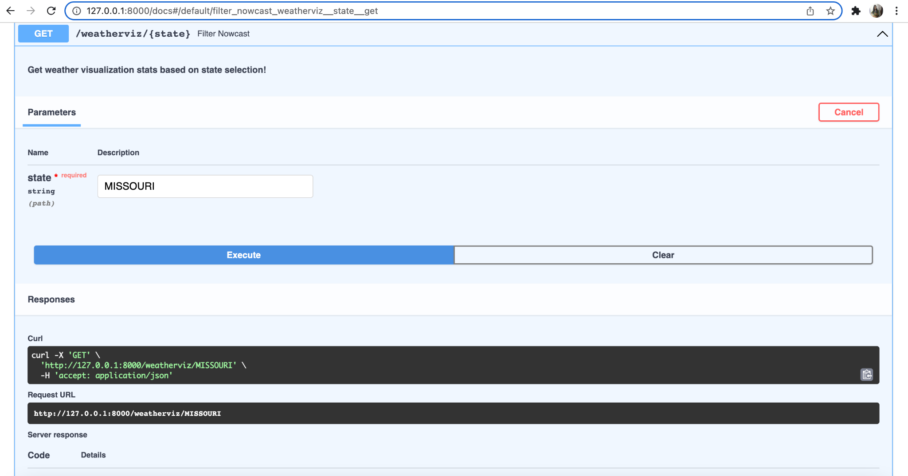

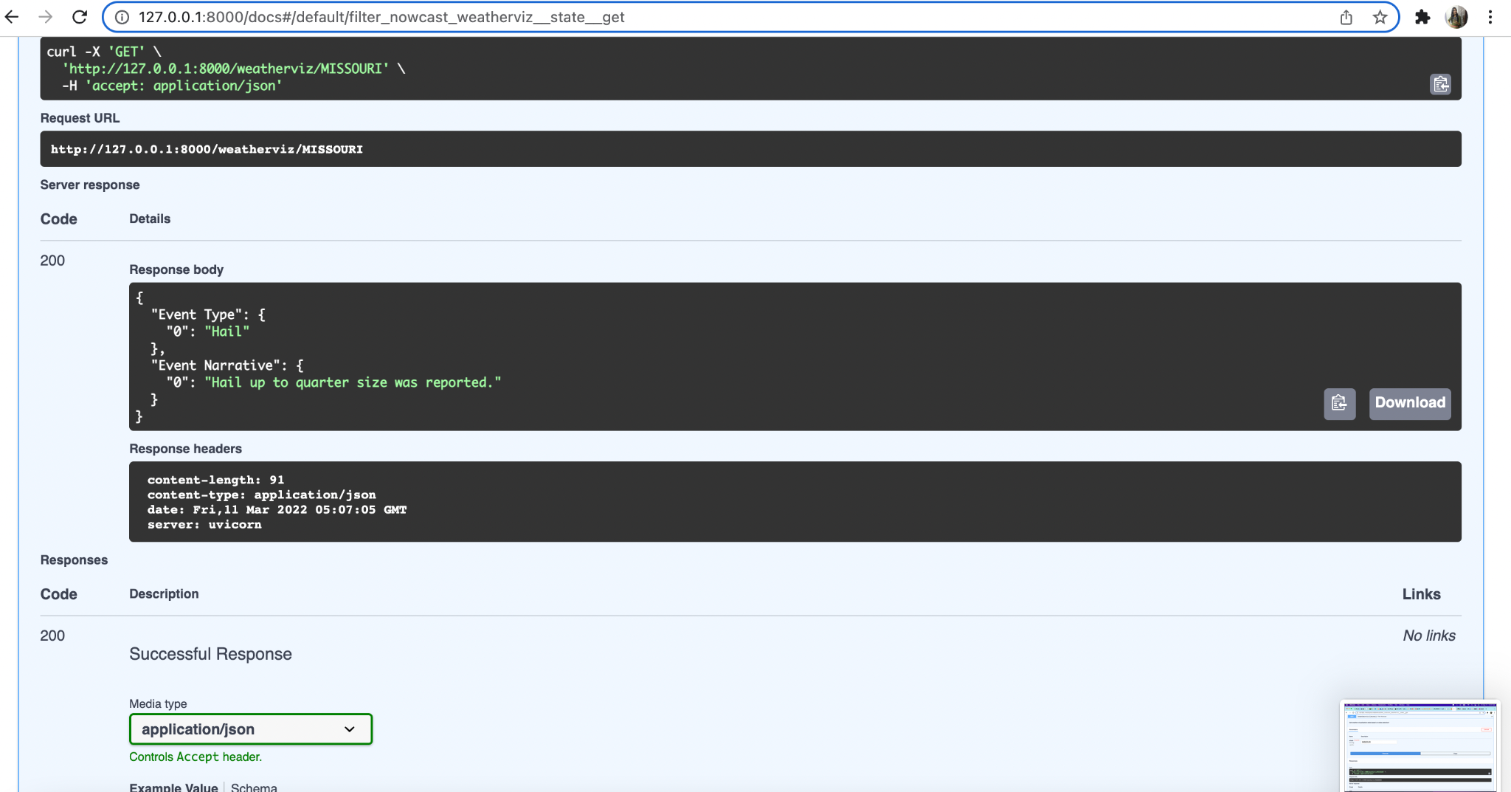

## Test cases to illustrate how to use the API

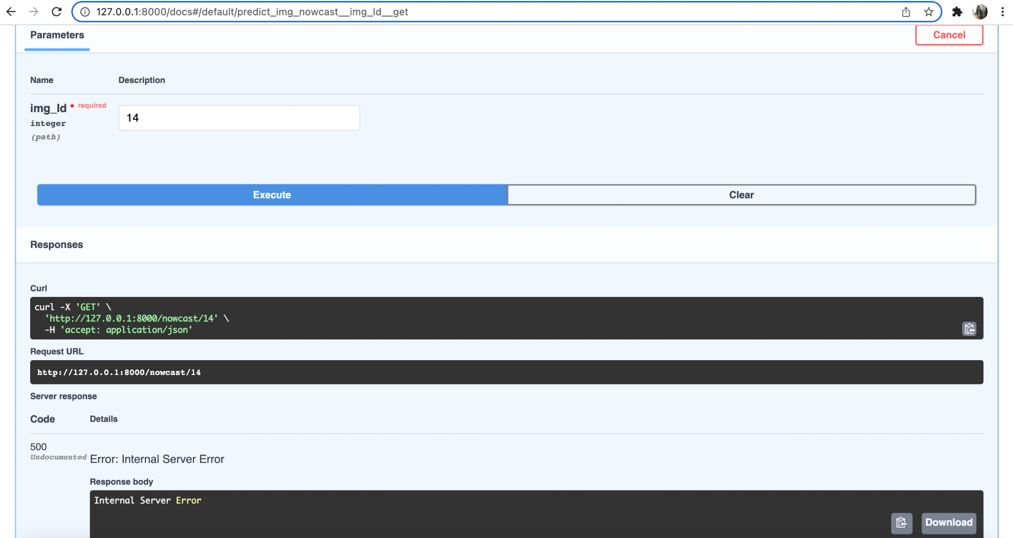

# 

# Conclusion

1. We have generated nowcast for the next few hours and rendered 12 nowcast images.
2. Enabled users to filter the event type and event narrative for the selected state from the drop down menu.

# References

1. <https://realpython.com/fastapi-python-web-apis/#path-parameters-get-an-item-by-id>
2. <https://learning.postman.com/docs/getting-started/introduction/>
3. <https://www.youtube.com/watch?v=vpTAqnAbowo>
4. <https://github.com/gretelai/gretel-blueprints>
5. <https://nbviewer.org/github/MIT-AI-Accelerator/eie-sevir/blob/master/examples/SEVIR_Tutorial.ipynb>
6. <https://gretel.ai/blog/walkthrough-create-synthetic-data-from-a-dataframe-or-csv>